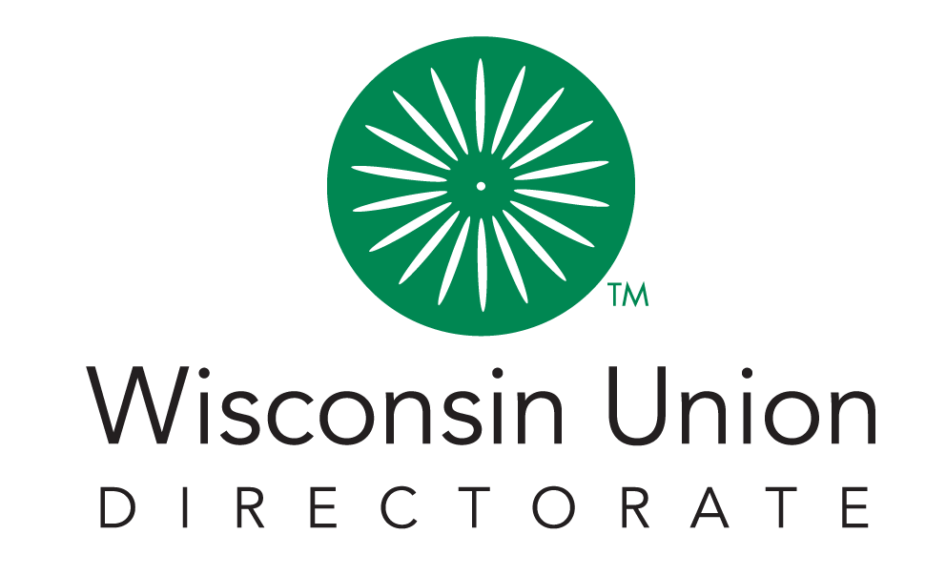

Union Council 2021-2022
____________________________

Meeting Agenda - 4/18
5:00 PM - 7:00 PM CST, April 18th, 2022 | Location: Pyle Center Rm 335

Call Meeting To Order | 10 min (5:00pm-5:10pm) | Liam
- Land Acknowledgement
- Approval of March 21st Meeting Minutes*
Open Forum | 20 min (5:10pm-5:30pm)
- Open Forum
New Business | 50 min (5:30pm-6:20pm)
- Presentation of the PAC Budget
- Presentation of Hoofers Budget
- Dining and Hospitality DEI food policies
- Homecoming Executive Board Approval
- Admin Hiring Shortage Recommendation
Union Advisory Boards | 5 min (6:20pm-6:25pm) | Julia, Liam, Sydney, Evanka
- Advisory Board Updates
  - Admin (Julia)
  - Dining and Hospitality (Liam)
  - Facilities (Sydney)
  - Social Education (Evanka)
Officer Report | 15 min (6:25-6:40pm) | Liam, Sydney, Evanka
- President (Liam)
- VP of Internal Relations (Sydney)
- VP of External Relations (Evanka)
- Secretary Update (Mark)
- Treasurer Update (Susan)
Updates | 25 min (6:40pm-7:00pm)
- ASM Update
- SSFC Update
- Dean of Students Update
- Summer Programming Update (Heidi)
Adjourn* | (7:00) | Liam

