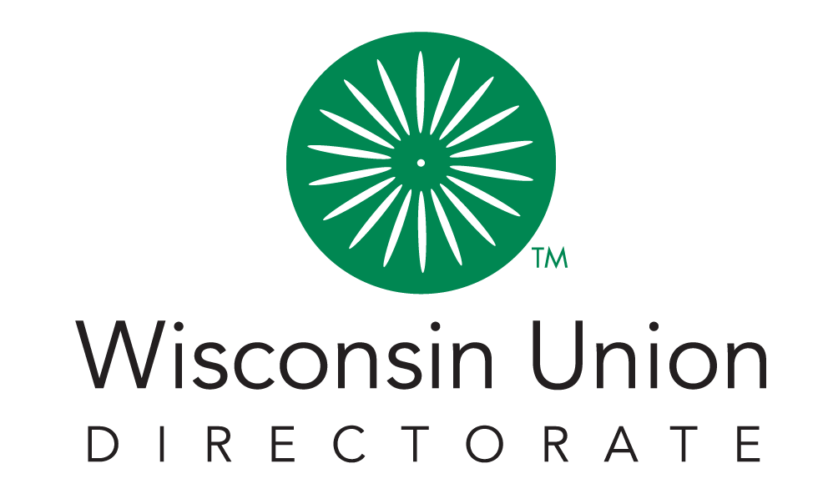

Union Council 2022-2023
____________________________

Meeting Agenda - 11/29
5:30PM-7:30 PM CST, November 29th, 2022 | Location: Memorial Union

Call Meeting To Order | 10 min | Lauren
- Land Acknowledgement
- Approval of October Meeting Minutes
Open Forum | 20 min
- Open Forum
New Business | 40 min
- Directors visit and Goals presentation (Lauren and Marie)
Officer Report | 15 min
- President (Lauren)
- VP of Internal Relations (Jasmine)
- VP of External Relations (Saehin)
- VP of Resources and Operations (Brady)
- Secretary Update (Mark)
- Treasurer Update (Susan)
Union Advisory Boards | 15 min
- Advisory Board Updates
  - Admin (Jasmine)
  - Dining and Hospitality (Saehin)
  - Facilities (Brady)
  - Social Education (Lauren)
Updates | 25 min
- ASM Update
- SSFC Update
- Dean of Students Update
Adjourn* | 7:30pm | Lauren

